**To:** Prof. Jie Yang, EE-286 Section 1

**From:** Team 5, EE-286 Section 1

Evan Genuise, Mason Gerace, William McGerty, Aidan Nash, and Joshua Pollock

**Date:** October 19, 2018

**Subject:** Project 2: Schematic and Part List

**Introduction:**.

In this memo, we will be taking a look at our potential circuit design and creating a parts list of what’s needed.

**Schematic:**

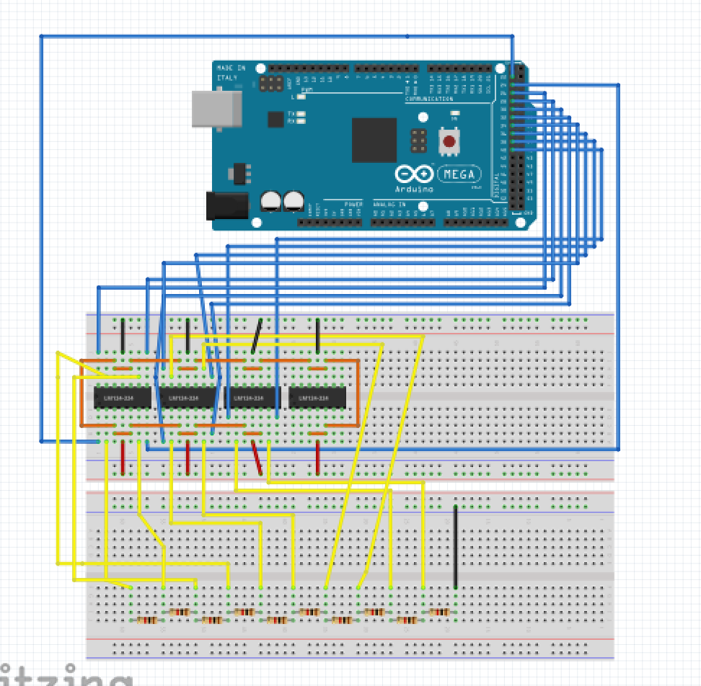

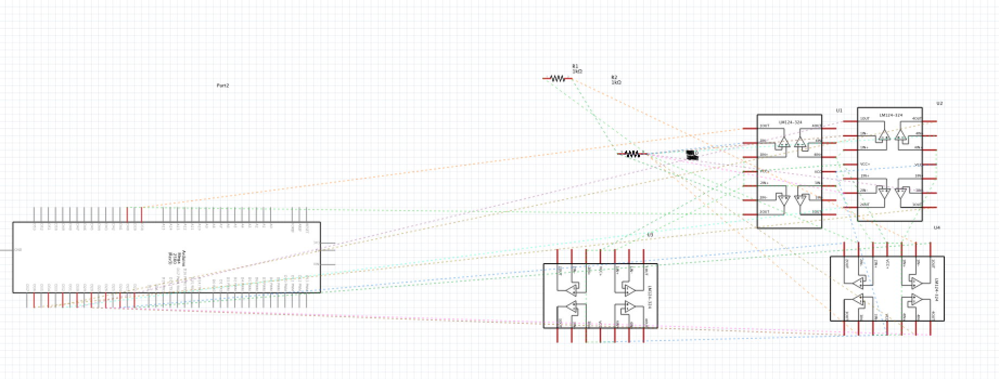

**Parts List:**

* LM324 x4
* Arduino kit
  + Jumper wires
  + LEDs x10
  + 4 7-segment display
  + LCD
  + 1k ohm resistors x10
  + Data cable

With these parts we will be able to assemble our circuit.

**Conclusion:**

With this memo completed, we will be able to begin assembling our circuit. This parts list can easily be expanded if needed but is currently what our circuit will be using.

**Attachments:** none